popcorn.R

Samuel

Tue Dec 04 15:38:45 2018

# Homework 10  
# Sam Tenney  
  
# Read in the data  
popcorn <- read.table(text = "Brand,Temp,Box,Bag,% Popped  
Expensive,Room,1,1,84  
Expensive,Frig,1,2,76  
Expensive,Room,2,3,86  
Expensive,Frig,2,4,86  
Expensive,Room,3,5,91  
Expensive,Frig,3,6,84  
Generic,Room,4,7,74  
Generic,Frig,4,8,87  
Generic,Room,5,9,84  
Generic,Frig,5,10,83  
Generic,Room,6,11,83  
Generic,Frig,6,12,90", header = TRUE, sep = ",")  
  
# Look at the data  
str(popcorn)

## 'data.frame': 12 obs. of 5 variables:  
## $ Brand : Factor w/ 2 levels "Expensive","Generic": 1 1 1 1 1 1 2 2 2 2 ...  
## $ Temp : Factor w/ 2 levels "Frig","Room": 2 1 2 1 2 1 2 1 2 1 ...  
## $ Box : int 1 1 2 2 3 3 4 4 5 5 ...  
## $ Bag : int 1 2 3 4 5 6 7 8 9 10 ...  
## $ X..Popped: int 84 76 86 86 91 84 74 87 84 83 ...

head(popcorn)

## Brand Temp Box Bag X..Popped  
## 1 Expensive Room 1 1 84  
## 2 Expensive Frig 1 2 76  
## 3 Expensive Room 2 3 86  
## 4 Expensive Frig 2 4 86  
## 5 Expensive Room 3 5 91  
## 6 Expensive Frig 3 6 84

tail(popcorn)

## Brand Temp Box Bag X..Popped  
## 7 Generic Room 4 7 74  
## 8 Generic Frig 4 8 87  
## 9 Generic Room 5 9 84  
## 10 Generic Frig 5 10 83  
## 11 Generic Room 6 11 83  
## 12 Generic Frig 6 12 90

# Repeated Measures plot  
library(lattice)  
xyplot(X..Popped~Temp|Brand, groups = Box, type = "a", ylab = "% Popped", xlab = "Temperature", main = "Part L: Repeated Measures Plot", data = popcorn)

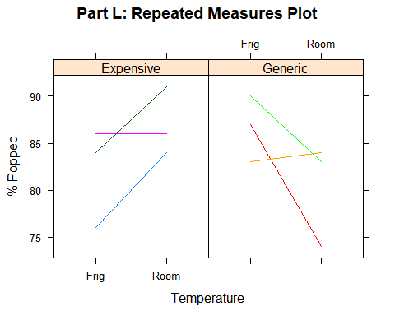

# Fit ANOVA Model  
popcornMod <- aov(X..Popped~Brand+Temp+Brand*Temp+Error(Box), data = popcorn)  
summary(popcornMod)

##   
## Error: Box  
## Df Sum Sq Mean Sq  
## Brand 1 9.257 9.257  
##   
## Error: Within  
## Df Sum Sq Mean Sq F value Pr(>F)   
## Brand 1 84.87 84.87 7.795 0.0268 *  
## Temp 1 1.33 1.33 0.122 0.7367   
## Brand:Temp 1 96.33 96.33 8.849 0.0207 *  
## Residuals 7 76.21 10.89   
## ---  
## Signif. codes: 0 '***' 0.001 '**' 0.01 '*' 0.05 '.' 0.1 ' ' 1

# Create plot for main effects  
xyplot(X..Popped~Brand,  
 type = "a",   
 ylab = "% Popped",   
 xlab = "Brand",   
 main = "Part O: Main Effects Plot (Brand)",  
 data = popcorn)

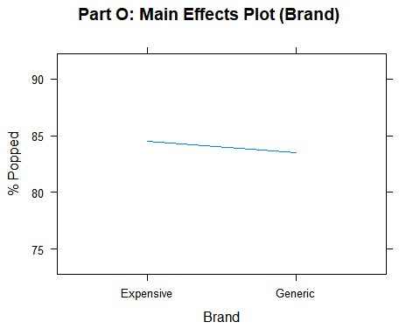

xyplot(X..Popped~Temp,  
 type = "a",   
 ylab = "% Popped",   
 xlab = "Temp",   
 main = "Part O: Main Effects Plot (Temp)",  
 data = popcorn)

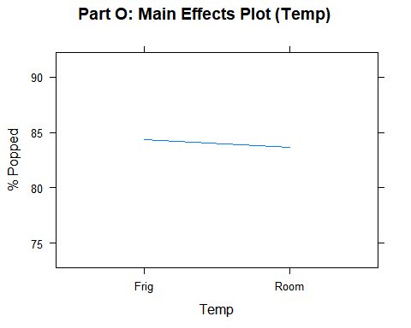

# Create a plot for the interaction effect  
interaction.plot(response = popcorn$X..Popped,   
 x.factor=popcorn$Brand,   
 trace.factor=popcorn$Temp,   
 ylab="Percentage of Kernels Popped",   
 xlab = "",   
 trace.lab = "",   
 main="Interaction Plot")

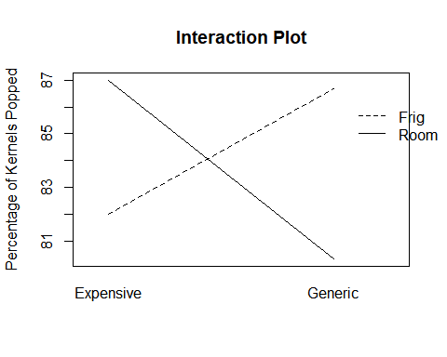

# Calculate grand mean, mean for each Brand, and the Brand effects  
mean(popcorn$X..Popped)

## [1] 84

brandMean <- aggregate(X..Popped~Brand, data=popcorn, FUN=mean)  
brandMean

## Brand X..Popped  
## 1 Expensive 84.5  
## 2 Generic 83.5

# Calculate the grand mean, the mean for each Temperature, and the Temperature effects  
mean(popcorn$X..Popped)

## [1] 84

tempMean <- aggregate(X..Popped~Temp, data=popcorn, FUN=mean)  
tempMean

## Temp X..Popped  
## 1 Frig 84.33333  
## 2 Room 83.66667

# Calculate the grand mean, the mean for each Brand x Temperature, and the interaction effects  
mean(popcorn$X..Popped)

## [1] 84

brandTempMean <- aggregate(X..Popped~Brand+Temp, data=popcorn, FUN=mean)  
brandTempMean

## Brand Temp X..Popped  
## 1 Expensive Frig 82.00000  
## 2 Generic Frig 86.66667  
## 3 Expensive Room 87.00000  
## 4 Generic Room 80.33333